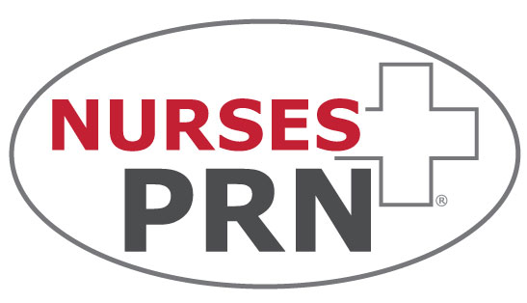

Job Description

Human Resource Manager

General Description
The Human Resource Manager will report directly to the President and work closely with the executive management team. The Human Resource Manager is directly responsible for the overall administration, coordination and evaluation of the human resource function. Their goal is to focus on developing and executing strategies to attract, develop, engage and retain employees in an innovative and ever-changing environment. This person will lead and manage a team of professionals who will create and implement objectives and policies that are aligned with state and federal laws.

Paygrade This position is salaried and exempt from payment of overtime compensation. In addition, a bonus/commission program and other incentives may be offered at the discretion of the executive management team of Nurses PRN.

Location This position will be staffed from the PRN St Louis office.

Direct Reports
Responsible for the direct supervision of human resource department staff. Works collaboratively with all other department leads and personnel.

Travel Negligible. May be required for purposes of hiring or termination of personnel.

Qualifications
- Bachelor’s Degree in Human Resources, Business or Organizational Development.
- 4 years of human resource management/business development experience.
- SHRM Senior Certified Professional (SHRM-SCP) or SHRM Certified Professional (SHRM-CP).
- Entrepreneurial spirit, with demonstrated experience working in fast-paced environment.
- Demonstrated track record of effectively leading teams, coaching, building partnerships and effectively managing and resolving challenges.
- Demonstrated experience and current knowledge of human resources, administration and corporate training.
- Ability to analyze and assess organizational needs and provide solutions.
- Recruiting and training of new talent
- Demonstrated ability to follow through on business plan.
- Strong relationship builder with experience leading diverse work teams.
- High integrity and ethical commitment as part of personal identity.
- Excellent oral and written communications.
- High level of computer literacy.
- Successful time management practices.

Representative Duties
- Attracts and retains talent and bench strength at all levels in the business and HR function. Partners with Management to recruit, interview and bring talent into the organization.
- Develops and implements programs focused on driving employee engagement across the entire employment life cycle.
- Annually reviews and makes recommendations to executive management for improvement of the organization's policies, procedures and practices on personnel matters.
- Maintains knowledge of industry trends and employment legislation and ensures organization's compliance.
- Maintains responsibility for organization compliance with federal, state and local legislation pertaining to all personnel matters.
- Communicates changes in the organization's personnel policies and procedures and ensures that proper compliance is followed.
- Partners with the executive management team to develop and deploy compensation, benefits and recognition programs to create a performance driven culture.
- Coordinates or conducts exit interviews to determine reasons behind separations.
- Consults with legal counsel as appropriate, or as directed by the President, on personnel matters.
- Works directly with department managers to assist them in carrying out their responsibilities on personnel matters.
- Drives succession planning identifying successors, developmental needs, talent gaps and strategic plans to fill those talent gaps.
- Develops and maintains a human resource information system that meets the organization's personnel information needs.
- Supervises the staff of the human resource department.
- Participates on committees and special projects and seeks additional responsibilities.
- Develops and implements HR strategies and initiatives aligned with the overall business strategy.
- Develops and implements robust workforce plans by analyzing strategic needs, seasonality, cyclicality, turnover, time to fill and other key metrics.
- Prepares, recommends, and maintains records and procedures for controlling personnel transactions and reporting personnel data.
- Classify and reclassify positions and write job descriptions.
- Administer all benefit programs to include enrollments, terminations, compliance and performance analysis. Serve as primary contact with providers including group health, dental, vision and life, unemployment and retirement plans.
- Designs personnel forms and directs the maintenance of personnel records for all offices.
- Support current and future business needs through the development, engagement, motivation and preservation of human capital.
- Keep teams advised of company/department progress and other critical communications.
- Maintain confidentiality regarding internal staff, client and candidate information.
- Create and monitor collaborative efforts amongst departments in an effort to carry out PRN mission and plans.
- Schedule and lead regular department/staff meetings.
- Enforce policies and procedures.

Measurement of Performance
- Effective management of daily operation within human resources and corporate training.
- Turn over of internal team members
- Growth of employees and revenue
- Ability to meet department specific goals as aligned with corporate wide strategic plan.
- Compliance with company policies and procedures.
- Maximize efficiency and cohesiveness within teams and amongst teams.
- Provide flexibility and cooperation in personal work schedule.
- Exhibiting a positive attitude and atmosphere of cooperation at all times.

This job description should not be construed to imply that these representative duties and qualifications are the exclusive standard for this position. Incumbents will follow such other instructions and perform any related duties as may be required by their supervisor.

PRN Health Services (Nurses PRN) is an equal employment opportunity employer, committed to promoting equal employment opportunities for all applicants and employees, regardless of age, race, color, national origin, religion, creed, handicap, disability, sex, sexual orientation, marital status, physical condition, political affiliation, membership in the national guard, state defense force or any other reserve component of the military of the United States or this state, and any other status protected under applicable federal or state law.

I have read the above job description and have been given the opportunity ask questions. My signature indicates that I am aware of my duties and responsibilities for said position. Furthermore, I understand that this job description does not imply an employment contract and that Nurses PRN is an at-will employer.

Employee Name - Printed

Employee Signature Date

