**Initial Sign-up Form:**

* Only lets you select one specialty, many nurses have multiple specialties
* First Name, Last Name, Phone, Zip, Occ and Spec need to be required. Even though they have and asterisk, you can submit if left blank.
* Let me put in a 5 digit phone number or letters, and no formatting requirements in phone box
* Let me put in a 6 digit zip code

**Contact section:**

* Middle Initial should not be required
* Change “Occupation” to “Certification”
* The specialty instruction should be at the top of the list of choices where the word “Specialty” is currently.
* Specialty I selected from the previous screen doesn’t stay, have to recheck it. This needs to carry over from the sign up to the application.
* No “other” field for specialty – we had asked this to match answer choices from RSS/CSS
* Additional phone should not be required
* City allows me to enter numeric values, should only allow alpha and “.” To allow for St. Point as an example
* See below. Says there is an error but no red boxes. After further testing it was being caused by me not choosing a specialty. There needs to be an error box if specialty is left blank.

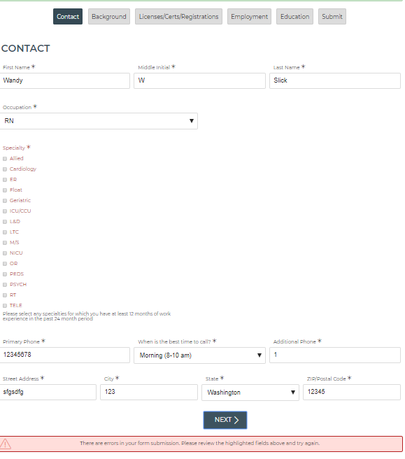

**Background section:**

* Preferred employment answer choices should be: Per Diem, Local Contract, Travel Contract, Permanent
* The form does not show you where your errors are when you submit. Just the red box at the bottom. We need to show the applicant where the errors are.
* I answered the first question (preferred employment) and left everything else blank and it still allowed me to submit successfully
* When you check Yes to “Have you been employed under another name?”, the question that pops up should read “Please list any other names you have been employed under”
* When you check Yes to “Have you previously worked for a healthcare staffing agency?”, there should not be a follow up question
* Have you previously worked for a healthcare staffing agency should not be required.
* Date bar is VERY long and drop down calendar doesn’t work
* A non-legal citizen can still proceed – is that how our current application is?

**Licenses section:**

* The form does not show you where your errors are when you submit. Just the red box at the bottom. We need to show the applicant where the errors are.
* Specialty certifications should not be required
* AHA certifications should not be required

**Employment section:**

* When submitting the page blank, it does not display an error message for “What specialties did you work”, What shifts did you work”
* Change the first question to “Facility Name”
* Change “address” to “Street Address”
* The “State” fields for the employer addresses should be dropdowns that allow you to choose a state, not text boxes (can type whatever you want)
* Let me put in 4 letters in the zip code
* The End Date needs to allow for someone to still be working there. This is most applicable to Per Diem where they are often currently working a permanent job while working per diem shifts for us. Can we add a “Still Working Here” option and then not require an end date?
* If they are still employed they won’t have a reason for leaving… We may need to add a question after Zip Code that states “Are you currently employed here?” if yes, they would just be required to add start date, if no they are required to add start date, end date, reason for leaving.
* Primary Reason for Leaving should have the following answer choices:

Still employed here

Contract expired

Found a better position

Better Pay

Better Hours

Facility closed

Position eliminated

Terminated

Other (Specify)

* “What Specialties Did You Work” need to have an Other (specify) option added
* Need to add the following question after “What Specialties Did You Work” – it is not required

What Electronic Medical Systems did you use at this facility?

Centricity

Cerner

ECS

Epic

Horizon (McKesson)

Meditech

PCC

Other (specify)

* “What shifts did you work?” should not be required, remove the asterisk
* The question “Did you work through an agency” was prefilled and should not be. This is a separate question from the one on the Background page.
* The question “Did you work through an agency?” should read “Did you work this job through an agency?”

Reference Section

* Question should read: Please provide at least one professional reference from this job (unit manager, direct manager, assistant manager, supervisor)
* Manager Name should be “Name”
* Manager Title should be “Title”
* Manager Phone should be “Phone”
* Let me put in a 5 digit phone number or letters, and no formatting requirements in phone box
* Need to add the following questions after Phone

|  |  |  |  |
| --- | --- | --- | --- |
| *Required | Dropdown | May we attempt to contact this person? | Yes  No |
|  | Checkbox | Would you like to add additional references from this job? | Yes  No – SKIP TO NEXT SECTION |

**Education section:**

* “Would you like to add additional education information?” This question/text box can be eliminated. Keep the button + ADD ANOTHER EDUCATION
* Change ADD ANOTHER EDUCATION to ADD ADDITIONAL EDUCATION

**Submit section:**

* Didn’t require me to put phone interview times, let me submit without any
* When choosing interview times, you can pick times that already happened on date of application
* We don’t do interviews on weekend days? They should not be allowed to pick a weekend date.
* Need to add a time zone choice after “Interview Time”

**On the Nurse dashboard, by clicking on Application I can view my submitted application. However, when I want to click through the different sections of the application, I have to use the arrows at the bottom of the page, and I can’t click on the specific sections at the top to navigate to the one I want. It let me do that when I was filling in the application.