Rockford
2018 Marketing Campaign
April, 2018

Market Situation
The Rockford region consists of 87 active facilities, including 20 Hospital/Clinics and 57 Long Term Care facilities. Geographically it stretches from the northern border of IL, to the mid part of IL including Peoria, IL. Nurses PRN has high awareness and market share in Rockford LTC but has low market share in hospital contracts (why?). The team recently expanded geographically into Peoria where there is very little awareness of Nurses PRN. The Rockford team recently raised pay rate by $1 / hour (why? What impact did this generate?). (How was this communicated?) (What opportunity does this present?)

Competitors (do these companies do both contracts and PD?)
- Super Nurse – small local Rockford agency
- Grapetree
- Maxim

Target Audience(s)

LTC – LPN and RN with one year experience in LTC

Hospital – RN with the following specialties….

The Rockford team describes the nurses in the Rockford region as:
- More blue collar
- “I” centric
- Not interested in building agency relationships
- Cold hard facts – no fluff
- “Harder” demeanor
- Difficult to encourage perm hospital nurses to take on per diem – they will take overtime with current hospital most of the time

Nurses PRN Numbers – Jan-Mar, 2018
- Average Weekly Temps Worked – 67
- Active Temps – 94

Business Goals
- Additional 50 active temps by year-end

 | Current | Proposed
Strategy | The overall strategy has been to treat all of Rockford as one general region. | We are going to take a more “city focused” approach
Facebook | $250 / Month | $1,000 / Month
 | Describe what we do today…. | Each month target a specific market. Key messages will be…. Use Look alike audience… List City by month…
Indeed | $980 / Month | $980 / Month
 | 7 sponsored jobs  -ER RN, 13 week contract - Rockford, IL  -LPN (Long Term Care) Rockford, IL  -Long Term Care RN - Moline, IL  -LTC RN Contract - Freeport, IL  -RN (Long Term Care) - Wheaton, IL  -Long Term Care LPN - Local Contract - DeKalb, IL  -Registered Nurse (Med Surg) - DeKalb, IL | We will continue to monitor and adjust the jobs list as needed.
IL Job Network  (NEW) |  | IL Job Network is a job board promoting jobs within the State of IL. They will email blast our jobs to qualified job seekers. If prospect clicks on the link they are taken to region specific landing page on our website and are encouraged to apply.
 |  | $1000 / month
 |  | Starting May 1, 2018
Email, text and call blitz (NEW) |  | To take advantage of our existing prospector list we are going to email/text/call blitz. Each RN and LPN prospect will receive an email, text and call from Nurses PRN over a two week time period.
 |  | Timing???
PDOP |  | The Per Diem Opportunity Page is a key addition to APP 2.0. The purpose of this page is to communicate key benefits of working per diem and let prospects know that Nurses PRN has lots of opportunities. A key feature is the zip code search that allows nurses to see how many facilities and shifts options they have near them.  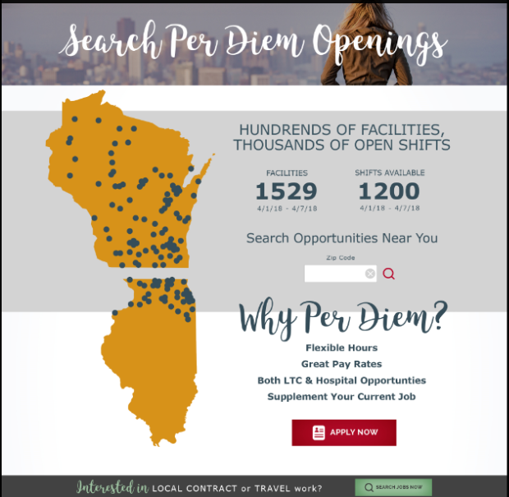
Metrics | Average gifted leads / week = 2  Q1 Submissions = 86  Active Temps Added =

