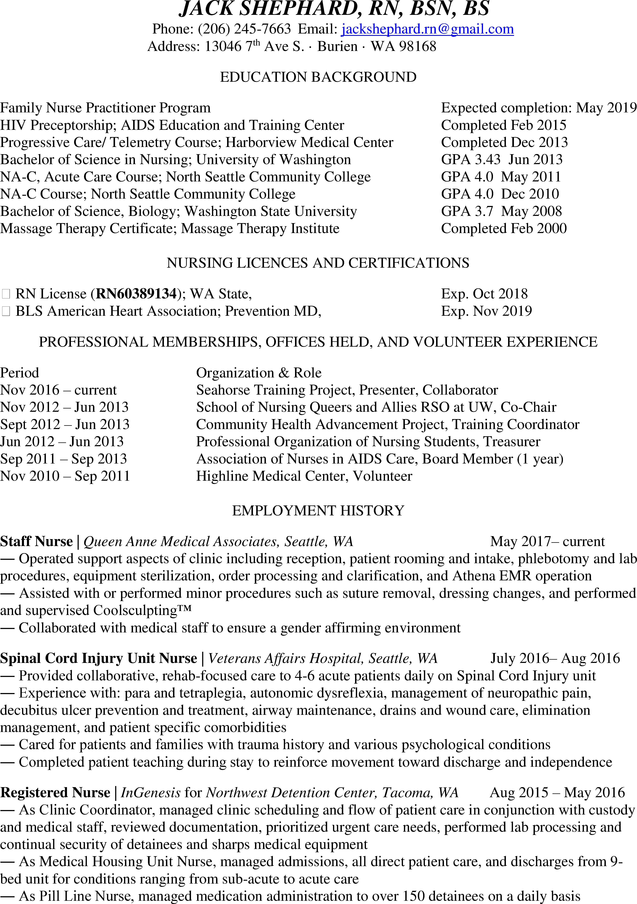

* Worked with detainees and fellow staff of diverse backgrounds, experiences, and languages with cultural competency

**Ortho-Spine Staff Nurse Resident** | *Overlake Hospital, Bellevue, WA* March 2015– May 2015

* Provided collaborative care to 4-6 acute patients daily on Ortho-Spine unit as nurse in training
* Experience with: total knee and hip replacements and associated movement precautions, fractures, pain management for peri-operative patients, drains and blood transfusions (autologous and banked), and patient specific comorbidities
* Cared for patients and families with diverse backgrounds and various communication barriers
* Completed patient teaching during stay and discharge

**Clinical Research Nurse** | *ASTHMA Inc. Clinical Research Center, Seattle, WA* May 2014 – Feb 2015

* Coordinated all aspects of 2 clinical research studies in the field of asthma and allergies
* Conducted study visits and performed procedures required for all studies, including lab procedures such as PBMC isolation and administration of investigational drugs
* Trained other study coordinators and staff on assisting with clinical studies

**Registered Nurse** | *Seattle Children’s Home, Seattle, WA* March 2014 – July-2014

* Provided collaborative, holistic nursing care in a sub-acute, locked facility for at-risk youth struggling with mental illness
* Referred patients to Seattle Children’s Emergency Room via AMR using standing and phone

authorized physician orders as needed

* Completed training and utilized “Safe Crisis Management” for children and teens

**Telemetry Staff Nurse Resident** | *Harborview Medical Center, Seattle, WA* August 2013– Jan 2014

* Provided holistic, collaborative care to 3-6 acute patients daily on Med/Surg/Telemetry unit as Telemetry trained staff nurse
* Experience with: CHF, a-fib, MI’s, endocarditis, PVD, DM, ortho, spinal, and soft-tissue trauma and wound care, liver failure, substance withdrawal/ CIWA, planned surgical procedures, SI, and assisting physicians with bedside invasive procedures such as chest tube insertions and paracenteses
* Cared for patients and families with diverse backgrounds and various communication barriers

**Nurse Technician** | *Harborview Medical Center, Seattle, WA* May 2012 – July 2013

* Performed nursing procedures such as IV removal, Foley, and FT placement under RN supervision
* Rounded on patients hourly, performing blood glucose checks, 1:1 feeding, ambulating and hygiene
* Conducted unit administration including answering call lights/ phones, relaying messages, arranging patient transport, updating patient census board, supporting Charge Nurse and processing physician orders

**In-home Caregiver** | *Home Instead Senior Care of Seattle, Seattle, WA* Feb 2011 – Jul 2011

* Provided general home care and emotional support to clients
* Assisted family in achieving optimal resolution of needs/problems
* Supported elderly to maintain their independence

**In-home Caregiver** | *Fedelta Care Solutions, Seattle, WA* Mar 2011 – Sept 2011

* Provided general home care and emotional support to clients
* Assisted family in achieving optimal resolution of needs/problems
* Supported elderly to maintain their independence

**Quality Control Analyst** | *Pacific Crossing LLC, Aliso Viejo, CA* Sept 2009 – Jun 2010

* Tested product quality against specified criteria utilizing standard operating procedures to ensured overall product quality was maintained according to cGMP and documented according to cGDP
* Monitored utility and environment to ensure sterile facilities for production of injectable drug
* Maintained QC lab, practiced safety procedures, and lab sanitization