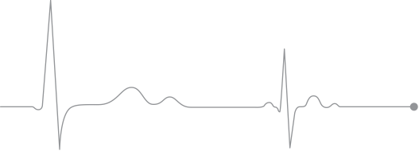

Allison Rauscher

registered nurse

608.333.5931

PROFILE

wiscallison@gmail.com

915 POPE ST,

LAKE MILLS, WI, 53551

Licenses &

Certifications

EDUCATION

ASSOCIATE DEGREE OF NURSING (R.N.)

Madison College

2017-2019

Wisconsin License #250219-30

LICENSED PRACTICAL NURSE

Madison College

2017

Wisconsin License #323174-31

Driven and passionate Registered Nurse delivering quality, safe, and

therapeutic patient care through leadership, commitment to quality, diversity, equity and inclusion. Trained in Basic Life Support, Epic, and Cisco Phone Systems, skilled in providing the best care for patient’s and their families. Developing knowledge, skills, and always looking for ways to help peers, patients, and their families. Excellent written and verbal communication and organization.

REGISTERED NURSE

Labor and Delivery, Unity Point Health- Meriter, Madison, WI | December 2020-Present

Meriter offers primary and specialty care, including the busiest birthing center in Wisconsin. Meriter is regularly recognized for outstanding quality and patient experience.

* Assessed maternal contractions, dilation, and fetal heart rate.
* Assist in maintaining pregnancy in antepartum mothers.
* Physically assessed maternal and newborns.
* Managed patients in labor, including induction assistance, epidural assistance, pain management, education, and delivery support.
* Assisted and circulated in operating room for cesarean sections, tubal, and emergency obstetric and gynecological procedures.
* Administered medications and immunizations.
* Assisted with breastfeeding and postpartum support/management.
* Charted via electronic medical records.
* Assisted with fetal demise.
* Collaborated with care management team, including anesthesiologist, physician or midwife, lactation nurse, and charge nurse.

REGISTERED NURSE

B4/6 Transplant Surgery, UW Health, Madison, WI | September 2019-December 2020

UW Health is one of the world’s foremost organ transplant programs offering a wide range of services including kidney and live-donor kidney, pancreas, liver and live-donor liver, heart, lung, heart/lung, intestine, multiple organ, islet cell and pediatric transplant services.

* Collected and analyzed data for research involving delirium in the liver transplant population.
* Participated in ICU training during the COVID-19 pandemic.
* Assessed, planned, implemented and evaluated care according to hospital policies, procedures, protocols and care standards.
* Respected differences in culture, values, lifestyle, coping skills and healthcare practices.
* Assessed physical and psychosocial needs with patients and families in order to implement appropriate changes in nursing care.
* Implemented practice policies and protocols relevant to patient population.
* Initiated multidisciplinary collaboration to positively impact the outcomes of health provided.

work experience

Teachable

Punctual

Proactive

Organized

Passionate

Adaptable

Driven

Intuitive

PERSONAL

SKILLS

BASIC LIFE SUPPORT(BLS)

Renewal In Progress

NEONATAL RESUSCITATION

Expires July 2023

ADVANCED CARDIAC LIFE SUPPORT

Expires October 2023