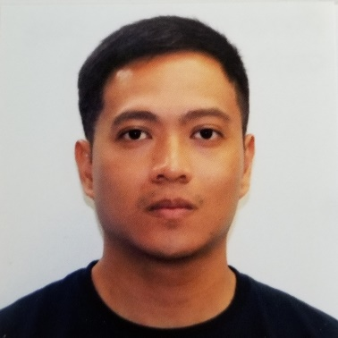**PAOLO RICARDO R. DIAZ, BSN, RN**

**5901 John F Kennedy Blvd., Apt. 3523**

**North Little Rock, AR 72116**

**paoloricardo.diaz@gmail.com**

**281-915-8354**

**QUALIFICATION SUMMARY:**

* Highly skilled professional for 8 years of solid OR experience.
* Have had US OR experience for 18 months working as a nurse traveller.
* Computer skilled with background in EPIC and CERNER hospital system.
* Flexible and can easily adjust to any situation.
* Can easily get along with everybody in the team.

**EDUCATION:**

* Capitol University, Cagayan de Oro City, Philippines

Bachelor of Science in Nursing, October 2007

**LICENSES:**

• RN Philippine License

✓ PRC Number: 0506181

• RN Northern Marianas License

✓ License Number: R16510

• RN Texas License

✓ License Number: 929166

* RN New York License

License Number: 756746-1

**EXPERIENCE:**

• **Cagayan de Oro Medical Center, Cagayan de Oro City, Philippines**

August 2019 – November 2020

Operating Room – Staff Nurse (Scrub/Circulating)

* Experience in scrubbing and circulating in general cases, orthopedic surgery, gynecologic surgery, urology, ENT.
* Familiar with Valleylab Cautery Machine, Suction Machine, Lica Microscope, Alcon Centurion Vision System Phacoemulsification, Coblator ENT Surgery System.
* **Midland Memorial Hospital**

**400 Rosalind Redfern Grover Pkwy,**

**Midland, TX 79701, USA (432) 221-1111**

February 2019 – July 2019

Circulating Nurse – Orthopedic/ENT/General Team

* Circulating Nurse in Orthopedic/Orthopedic trauma, General and General trauma, Urology, Plastics, ENT(BMT’s and T&A’s), and Dental in a 474 bed capacity Hospital.
* Have knowledge in Orthopedic equipments such as: Hana table, Jackson table, Beach chair, Amsco table, Arthroscopy equipments, Total(knees, hips, shoulders) Equipments, Aquamantys.
* Experience circulating in Laparoscopic cases such as, Lap Chole, Lap Appendectomy, Lap abdominal hernia repair, Lap abdominal colectomy, Gastric sleeve.
* Familiar with Sythes, Depuy, Zimmer/Biomet total joints, Arthrex.
* Have background in Cerner hospital system.
* Communicates professionally and effectively with other operating room staff and surgical team. Easy to get along with everybody.
* Provides intraoperative direct patient care and support to patients and their family members.
* **Rapid City Regional Hospital 353 Fairmont Blvd, Rapid City, SD 57701 (605) 755-1000**

January 2018 – November 2018

Circulating Nurse – Orthopedic/General Team

* Experience circulating in orthopedic trauma, sports medicine, and spine, general and general trauma, laparoscopic cases, urology, gynecologic surgery, plastics, ENT, and dental in a Level II Trauma Center.
* Familiar with Synthes trauma; Depuy and Zimmer/Biomet total joints; Arthrex sports medicine.
* Have background on Epic hospital system.
* Communicates professionally and effectively with other operating room staff and surgical team. Easy to get along with everybody.
* Provides intraoperative direct patient care and support to patients and their family members.

**REFERENCES:**

**Midland Memorial Hospital**

**400 Rosalind Redfern Grover Pkwy,**

**Midland, TX 79701, USA (432) 221-1111**

**Shawna Claeys**

Manager, Surgical Services

Midland Memorial Hospital, Midland, Texas

309-368-1846

**Rapid City Regional Health**

**353 Fairmont Blvd., Rapid City, SD 57701**

**Peggy O'Sullivan**

Director, Surgical Services

Rapid City Regional Health, Rapid City, South Dakota

605-755-2287

**Angie Bohling**

Manager, Surgical Services

Rapid City Regional Health, Rapid City, South Dakota

605-755-8608