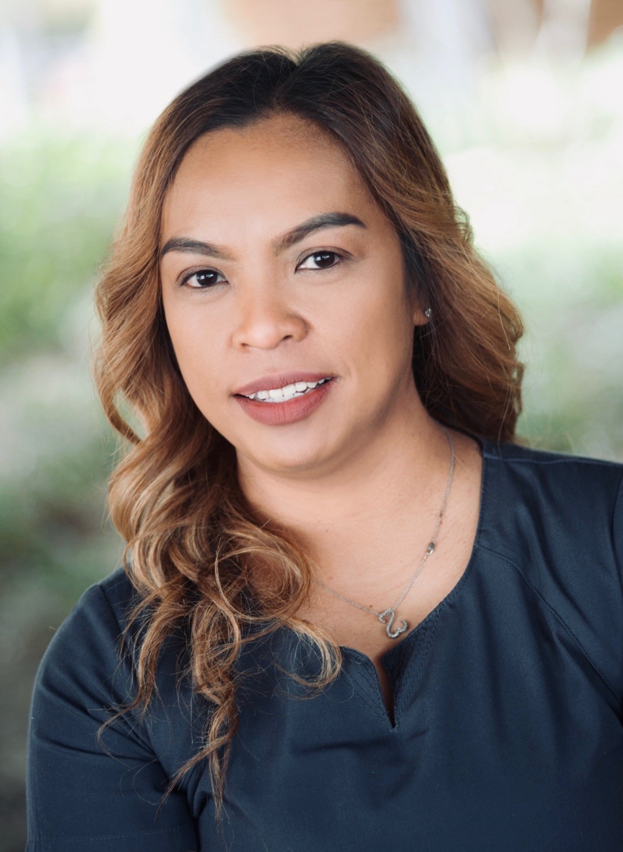 |  | Annabelle StJohn  RN
Profile  Looking for a position as a Registered Nurse to utilize earned skills and knowledge while providing a compassionate quality care for patients.  I have graduated on May 202-0 with Associate in Nursing and I have been an experienced LVN for two years prior to that. I am dedicated in providing upmost care to all my patients. I am also currently pursuing my BSN degree and hoping to complete this degree soon. I am also fluent in the Tagalog language.  Contact  PHONE:  214-218-3212  EMAIL:  belle121981@gmail.com  Reference:  Available upon request |  | EDUCATION  Grayson College  January 2019-May 2020 ▪ Associate in Nursing (bridge program LVN-RN)  864 hours of supervised clinical and laboratory experience.  Nursing III- nursing health and illness, Clinical III, Nursing IV nursing health and illness, Clinical IV  Grayson College  August 2017-July 2018 ▪ Vocational Nursing Program  Completed all theoretical and clinical requirements for the program.  WORK EXPERIENCE  KPG healthcare staffing- RN (Select Specialty Hospital, OKC)  July 2020 – Current  Assisted with direct patient care and provided medical care to patients, under the guidance of a Physician in acute setting. Administered PO, IV, IM, SQ and PEG tube medication administration, wound care, trach care, PICC line and Central line care. Vent care.  All American Staffing Agency- LVN-RN  November 2019 – Current  Assisted with direct patient care and provided medical care to patients, under the guidance of a registered nurse and physician. PO, IV, IM, SQ and PEG tube medication administration, wound care, trach care, PICC line and Central line care.  Oakridge Nursing Home- LPN  August2018 – March 2020  Assisted with direct patient care and provided medical care to patients, under the guidance of a registered nurse and physician. PO, IV, IM, SQ and PEG tube medication administration, wound care, trach care,  Woodlands Rehab and Suites- LVN  November 2018 – Feb 2020  Assisted with direct patient care and provided medical care to patients, under the guidance of a registered nurse and physician. PO, IV, IM, SQ and PEG tube medication administration, wound care, trach care,  Licenses and credentials:  License Voactional Nurse (LVN) - Obtained license on September 2018  Registered Nurse (RN) - Obtained license on July 2020  BLS- Certification is current.  ACLS- Certification is current  LICENSE AND CREDENTIAL:

