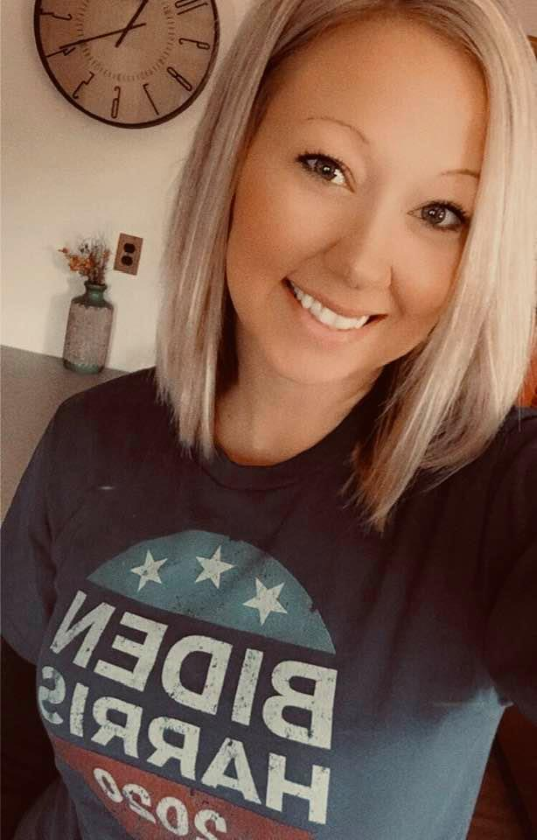 |  | Kristine Rench
Profile  I am a compassionate, newly graduated, licensed practical nurse. I have experience with Inmates, addicts, elderly, and adolescence. During my clinical experience as a student at Kaskaskia college I was able to apply my nursing skills hands on in a variety of settings. I am able to successfully perform catheter insertion, IV insertion, phlebotomy, medication administration, wound care, physical therapy, charting, therapeutic communication, maintaining patient safety, assisting with activities of daily living, problem solving, quick thinking, newborn/post-partum care, and working together as a team  Contact  PHONE:  618-666-3145  EMAIL:  kristinemarierench@gmail.com |  | WORK EXPERIENCE  LPN: Gateway Foundation, Caseyville, IL  March 2021- July 2021  Administering medications, monitoring clients having withdrawal symptoms, Monitoring clients when giving suboxone, providing therapeutic communication and emotional support to clients. Charting, Documentation, Assisting Dr. with patients, Scheduling Dr. appointments. Admissions/Transfers. Knowledge about drugs/withdrawal. Controlled substance safety.  Phlebotomist: Wexford Health Sources:  Graham Correctional Center  March 2019- Feb 2021  Obtain blood samples from inmates. Counseled patients to ease fears, explain procedures and enhance cooperation during blood draws. Enhance infection control and sharps disposal procedures to protect patients, co-workers, and self. Labeled blood vials with critical information like time, date, name. Responsible for knowing how to safely store and spin blood specimens.  CNA: Wexford Health Sources  Graham Correctional Center  March 2019- Feb 2021  Routine checks, standard patient vitals, blood sugar, EKGs. Assistance with shaving, bathing, oral hygiene, feeding, other ADLs. Scheduling appointments. Documentation. Examine and addressed lacerations, contusions, ulcers, and physical symptoms to assess and prioritize need for further care. Fast paced work environment. Intakes. Transfers.  Kaskaskia College: Practical Nursing: 2019-2020  Kaskaskia College: Certified Nursing Assistant: 2013-2014  key skills and characteristics  - Medication administration, monitor fluids, collection of specimens.  - Knowledge in addiction, drugs/alcohol abuse, withdrawal  - Performing patient intakes, patient safety, creating a care plan  - Catheter insertion, CPR certified  - Wound management, G-tube care  - Phlebotomy, IV certified  - Experience in Infant, elderly, and mental health care.  - Experience in a correctional setting  - Compassionate, empathetic, non-judgmental, dedicated, hard worker.

WORK EXPERIENCE

CNA: Help At Home
Caring for multiple individuals in their home. Assisting with activities of daily living. Responsible for patient safety. Assist with feeding, ambulation, transfers, and bathing.

CNA: Help At Home: Volunteer.
Caring for special needs children in their homes. Helper at Fayco assisting special needs children and adults with their daily routine in a work environment. Making sure they get too and from work safely and on time. Assisting with activities of daily living.

CNA: Faith Country Side Nursing home
Caring for elderly in nursing home setting. Assisting with proper hygiene skills, toileting, dressing, feeding, keeping them hydrated, engage in activities, keeping a routine, shower, vital signs, listening and keeping them content, happy, and comfortable.

Kristine
Rench

References

Laura Weiss
618-580-9642
Employer – Help at Home

Renae Bettencourt
(618) 920-5035
Co-worker at Gateway foundation

Jennifer Christer
217-532-6961
Manager – Graham Correctional

Kara Edwards
217-313-3150

Co-worker – Graham Correctional

