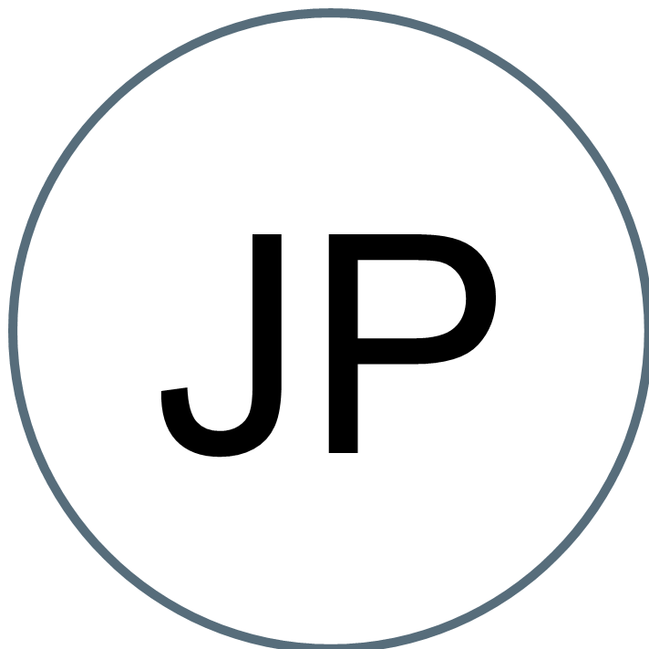 | Jennifer Puente        Kenosha, WI 53142 (262) 344-4972 jenniie123@gmail.com

Professional Summary | Dedicated and compassionate Registered Nurse (RN) with progressive career history in direct patient care, triage and care coordination in fast-paced environment. Proven to remain calm under pressure and skillfully handle difficult patients and high-stress situations. Consistently developing strong relationships with patients and families through empathetic communication, respectful attitude and excellent customer service.

Accomplishments | - Nurse Preceptor  - Nurse Educator to ER staff and new graduates  - Employee of the Month  - Summa Cum Laude Graduate  - Member of the Kenosha County Opioid Taskforce  - STEMI committee

Skills | - Medication Administration - Critical Thinking - Monitoring Vital Signs - Accurate Documentation - Care Coordination - Procedure Assistance - Patient Condition Monitoring - Trauma recovery - Emergency Procedures

Work History | Registered Nurse 01/2017 to Current  Froedtert South Hospital | Pleasant Prairie, WI  - Administered medications via oral, IV and intramuscular injections and monitored responses.  - Provided direct patient care, stabilized patients and determined next course of action.  - Monitored patient condition by interpreting and tracking EKG readings, identifying irregular telemetry readings and updating team members on changes in stability or acuity.  - Trained new nurses in proper techniques, care standards, operational procedures and safety protocols.  - Teamed on trauma and emergency interventions involving serious head injuries, gunshot wounds and thoracic trauma.  - Coordinates patient teaching.  - Recognizes the occurrence of life - threatening situations and emergencies and takes appropriate actions a timely manner.  - Triage RN  - Charge / Resource RN  Registered Nurse 11/2021 to 02/2022  Ascension All Saints Hospital - Agency | Racine, WI  - Implemented medication and IV administration, catheter insertion and airway management.  - Educated patients, families and caregivers on diagnosis and prognosis, treatment options, disease process and management and lifestyle options.  - Administered medications and treatment to patients and monitored responses while working with healthcare teams to adjust care plans.  - Collaborated with physicians to quickly assess patients and deliver appropriate treatment while managing rapidly changing conditions.  Student Nurse Intern 01/2014 to 12/2016  Froedtert South Hospital | Pleasant Prairie, WI  - Collaborated with nurse preceptors and other medical staff to achieve quality patient outcome goals.  - Monitored medications, noted side effects and reported issues to senior staff.  - Transported patients between unit rooms and scanning locations for diverse procedures.  - Helped physicians complete procedures such as lumbar punctures by supporting patients and organizing necessary supplies.  - Assisted patients with personal hygiene requirements and monitored conditions to update nursing staff.  - Administered close patient care, checked vital signs and monitored telemetry.

Education | Bachelor of Science | Nursing 04/2019  Herzing University, Kenosha, WI  Associate of Science | Nursing 12/2016  Gateway Technical College, Kenosha, WI

Languages | Spanish  Native or Bilingual

Certifications | - State of Wisconsin Registered Nurse  - PALS - Pediatric Advanced Life Support  - ACLS - Advanced Cardiovascular Life Support  - TNCC - Trauma Nursing Core Course  - NIH Stroke - National Institutes of Health Stroke  - BLS Instructor - Basic Life Support  - NRP - Neonatal Resuscitation Program  - Ultrasound Guided IV Insertion
.

