

ELIZABETH ASMONDY

**Registered Nurse, MSN**

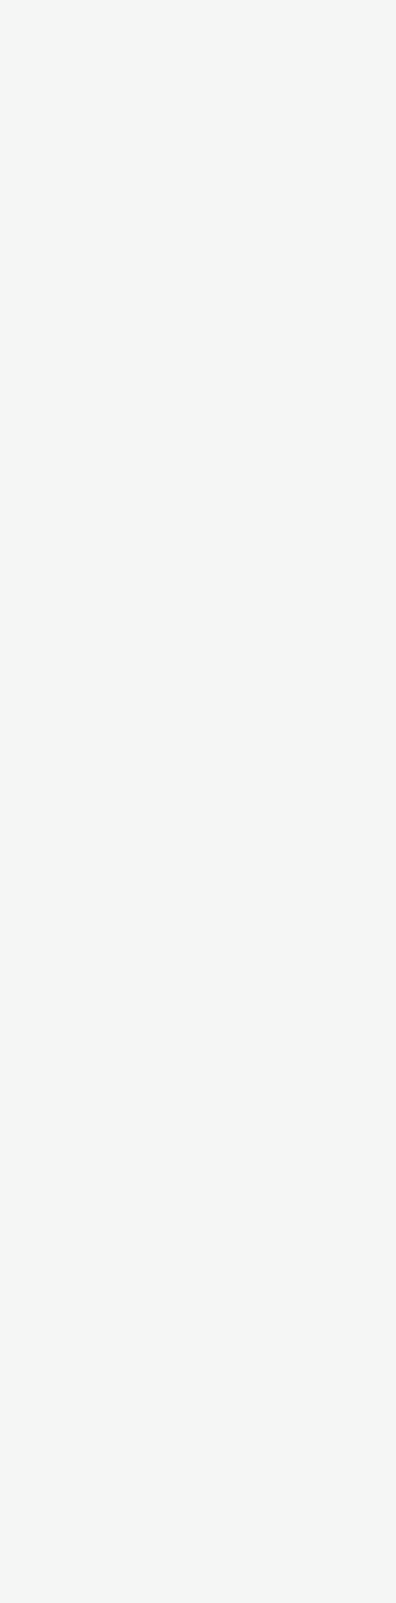C:\Users\abdou\Desktop\Resumes for Customer\Customer Project\Resume 1\address.pngC:\Users\abdou\Desktop\Resumes for Customer\Customer Project\Resume 1\phone.pngC:\Users\abdou\Desktop\Resumes for Customer\Customer Project\Resume 1\mail.png

**NURSING STUDENT CLINICAL ROTATION- OB/GYN, MED/SURG**

*Ascension Healthcare- All Saints, Racine, WI / May 2021-Aug 2021*

* Monitor patient health status and change in condition
* Coordination with care team on patient treatment plans
* Assess individual needs including diet, referrals, home care
* Medication administration- all routes.

**COVID-19 VACCINATOR**  
*Marquette University, Milwaukee, WI / Mar 2021- Apr 2021*

* Maintain clean technique
* Knowledge of intramuscular injection procedure
* Patient education on Moderna vaccine and aftercare

**REGISTERED NURSE**

*Racine County Jail, Racine, WI/ Aug 2021-present*

* New inmate medical clearance screens and health assessments
* Daily management of chronic conditions and sick calls
* Emergency response
* Mental health, chemical withdrawal, and Vivitrol experience

**CERTIFICATIONS**

-BLS/CPR

-Institute for Healthcare Improvement: Quality Improvement

-Suturing Skills

-Advanced Practice Physical Assessment  
-Advanced Practice Pharmacology

-EPIC documentation

-Medication Administration

-Wound Care

-Blood Glucose Testing

-

**SKILLS**

**MARQUETTE UNIVERSITY  
Milwaukee, WI**  
*Master of Science (M.S.) Nursing   
(Aug 2021)*

**UNIVERSITY OF WISCONSIN-MILWAUKEE  
Milwaukee, WI**  
*Bachelor of Arts (B.A.) Education  
(May 2013)*

[easmondy@gmail.com](mailto:easmondy@gmail.com)

(847) 409-4324

3817 Wyoming Way, Racine, WI, 53404

**EDUCATION**

**EXPERIENCE**

Motivated individual with a Master’s degree in nursing who is seeking to use earned skills and knowledge in a healthcare role. Possesses the ability to efficiently operate within independent and team environments. Excellent organizational skills and a dedication to patient-oriented care will be used to perform and exceed all responsibilities and objectives.

**CAREER OBJECTIVE**