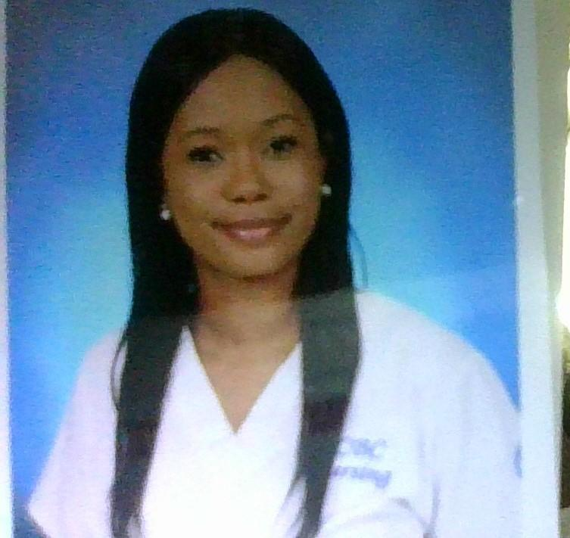 |  |  |  | Sherrie  Davis- RN

Experience
Registered Nurse Actively employed
Lifebridgehealth Sinai
Level II Trauma Center
ICU Step Down/IMC

On this 36 bed step down critical care unit patients require closer in depth monitoring-respiratory, cardiac-telemetry, continuous pulse oximetry monitoring in each patient room. An extensive skill set is quickly developed and used to manage 1:4 patient ratios.

Observation and assessment are one of the most important skills that are quickly sharpened on this unit. By closely observing patients, I am able to react/report changes in the pt status to the MD, PA, or NP. Identifying signs and symptoms of critical conditions such as hypotension, sepsis, CO2 retention, adverse reactions related to sedatives. Identify cardiac emergencies, such as SVT, V Fib or bradycardia and respond appropriately. Also, assess and monitor thermal regulation, identifying subtle changes like increase in work of breathing using accessory muscles, that leads to acidodic changes that would lead to respiratory interventions like administering oxygen through non rebreather mask, high flow nasal cannula, or BIPAP. In addition to the aforementioned skills I also am responsible for the administration of high-risk medications such as TPN, Lipids, and the following drips heparin, insulin, dopamine, amiodarone, and PCA pumps.

LPN
Lifebridge Health Sinai
Level II Trauma Center
ICU Step Down/IMC 9/2019 – Currently Employed

I perform tasks related to a plan of care for acutely or critically ill patients. Managed care for patients with acute pulmonary disorders such as COVID, Acute hypoxic respiratory failure, COPD, Asthma, Lung Cancer etc. Skilled and knowledgeable with oxygen therapy ranging from nasal cannula up to high flow nasal cannula, Bipap, and in some COVID + cases ventilation. In addition to pulmonary care, I also care for patients with an array of cardiac issues CHF, Cardiac Stenosis, SVT, and MI’s using continuous telemetry monitoring and pulse oxygenation monitoring. The Intermediate Care Unit cares for almost any and every medical condition, we see and treat patients who are direct admits from the ER, or Upgrades from MS units, PEG placement, Bariatric, Cath lab, TPA, TURP, GSW, we treat patients with Neurological deficits from strokes. EtOH withdrawal, psych patients. Responsibilities as a Step-Down Nurse my duties include: administering prescribed medications and operating life measuring equipment. Reviewing data produced from various medical equipment and act upon findings. Giving updates to the patient and their families regarding their condition. Reporting significant findings to the provider. Educating patients about the best ways to adjust to major lifestyle changes.

LPN
PrimeCare Corrections
Baltimore County Detention Ctr September 2020

Intake Nurse, perform in-depth triage prior to accepting inmates into the facility. The triage covers current and past medical health history. In addition to obtaining the patient's medical history, we thoroughly screen for mental health and substance abuse history. The intake nurse is responsible for all patients being housed in the intake department prior to being assigned a housing unit. While under our care we are responsible for managing the care required for each inmate's health conditions. We have mandatory detox checks, on any inmate who tests positive for narcotics. Medication administration, baseline vitals assessment, glucose testing, as well as TB planting is all performed in the intake department by the LPN.

Screening Nurse Freshly Inc. Contractual April 2020- July 2020

On-site nurse, screening employees for symptoms of Covid-19
Administered questionnaires to employees to determine potential exposure. Provided patient education regarding the importance of screening and health preventative measures.

Multi-Functional Tech- Franklin Square Med Center- Intermediate Care and Observation unit​ ​12/2017-05/2019

Multi-Functional Tech- Emergency Dept Franklin Square Hospital 06/2018-05/2019

Ambulatory office setting as Medical Assistant --- 16 years

Education
HCC, Harford County, MD
Registered Nursing Program Graduated 6/2021

CCBC, Catonsville,MD
- Practical Nursing Program Graduated 8/2019
- Registered Nursing Program 8/2016 – 03/2018

References
Emmanuel Paron RN, Unit Charge Nurse 443-825-6185
Benjamin Sanchez BSN, RN 619-312-5889
Minnie Ngugi 209-670-7139
Demetria Jones RN, BSN Asst Nurse Mgr 443-421-7483
Teona Jackson LPN Charge 410-952-8192

 |  | Baltimore, MD 21239
 |  | 443-653-0531
 |  | sjoidavis@yahoo.com
 |  | ACLS Certified

