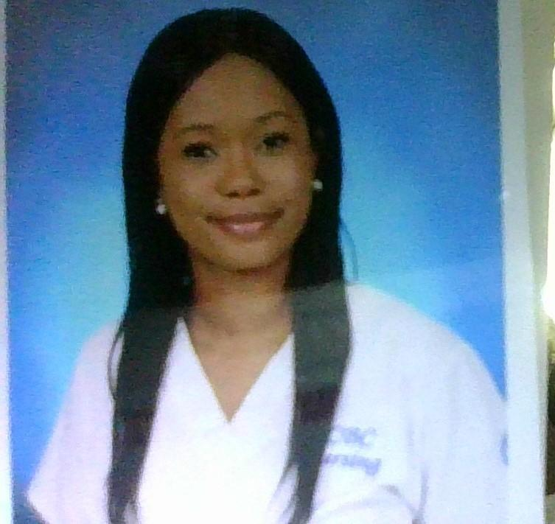 |  |  |  | Sherrie  Davis- RN

Experience
Registered Nurse 6/2021— Currently Employed
LBH Sinai
ICU Step Down/IMC

As a Step-down nurse I am responsible for taking care of patients who require special monitoring, frequently including patients recently released from the ICU.Responsibilities as a Step-Down Nurse my duties include: administering prescribed medications and operating life measuring equipment. Reviewing data produced from various medical equipment and act upon findings. Giving updates to the patient and their families regarding their condition. Reporting significant findings to the provider. Educating patients about the best ways to adjust to major lifestyle changes.

LPN
Lifebridge Health Sinai
Level II Trauma Center
ICU Step Down/IMC 9/2019 – Currently Employed

I perform tasks related to a plan of care for acutely or critically ill patients. Managed care for patients with acute pulmonary disorders such as COVID, Acute hypoxic respiratory failure, COPD, Asthma, Lung Cancer etc. Skilled and knowledgeable with oxygen therapy ranging from nasal cannula up to high flow nasal cannula, Bipap, and in some COVID + cases ventilation. In addition to pulmonary care, I also care for patients with an array of cardiac issues CHF, Cardiac Stenosis, SVT, and MI’s using continuous telemetry monitoring and pulse oxygenation monitoring. The Intermediate Care Unit cares for almost any and every medical condition, we see and treat patients who are direct admits from the ER, or Upgrades from MS units, PEG placement, Bariatric, Cath lab, TPA, TURP, GSW, we treat patients with Neurological deficits from strokes. EtOH withdrawal, psych patients.

In this unit, you learn to hone your skills like NG tube insertion, straight and indwelling catheter insertion, wound prevention, and care, IV insertion and therapy, bladder scanning, assist with ultrasound-guided IV insertion, trach care. Observation and assessment are one of the skills that are quickly sharpened in this unit. By closely observing patients, I am able to react/report changes in status to MD, PA, or NP. Identifying signs and symptoms of critical conditions such as hypotension post-operatively, CO2 retention from inadequate airway management, or chemical restraints and call for rapid response. Identify cardiac emergencies, such as SVT or bradycardia on Full code patients and respond appropriately. Also, assess and monitor febrile conditions, an increase of work of breathing using accessory muscles, assist and cosign as a second nurse witness in the administration of high-risk medications such as TPN, Lipids, Heparin drips, and Insulin drips.

PrimeCare Corrections
Baltimore County Detention Ctr September 2020-Current PRN

Intake Nurse, perform in-depth triage prior to accepting inmates into the facility. The triage covers current and past medical health history. In addition to obtaining the patient's medical history, we thoroughly screen for mental health and substance abuse history. The intake nurse is responsible for all patients being housed in the intake department prior to being assigned a housing unit. While under our care we are responsible for managing the care required for each inmate's health conditions. We have mandatory detox checks, on any inmate who tests positive for narcotics. Medication administration, baseline vitals assessment, glucose testing, as well as TB planting is all performed in the intake department by the LPN.

Screening Nurse Freshly Inc. Contractual April 2020- July 2020

On-site nurse, screening employees for symptoms of Covid-19
Administered questionnaires to employees to determine potential exposure. Provided patient education regarding the importance of screening and health preventative measures.

Multi-Functional Tech- Franklin Square Med Center- Intermediate Care and Observation unit​ ​12/2017-05/2019

Assist RN with the care of telemetry patients -Performed task related to plan of care for very ill patients who suffered from CHF, Cardiac stenosis, SVT patients, MI’s, ETOH withdrawal, Pulmonary disorders such as COPD, Lung Cancer, Tracheostomy, Sepsis patients, Neuromuscular degeneration, Bariatric patients, -Observed patient status and, quickly reacted/reported the change in patient status -Identified signs and symptoms of dehydration, performed bladder scans to assess urinary retention
-Monitored for CAUTI’s while caring for clients with indwelling catheters assisted with foley insertion, or placed and maintained pure wick if that was more appropriate while maintaining proper skincare
-Identified fall risk patients, assist with safe ambulation reinforce safety measures such as keeping client items and call bells in reach, ensured proper identification for fall risk patients were in place, ensured bed alarms were on
-Performed glucometer checks using Accu-check
-Assisted in Rapid Response, and codes

Multi-Functional Tech- Emergency Dept Franklin Square Hospital 06/2018-05/2019
-Triage incoming emergency patients, maintain patient flow for triage area, assisted flow chief with up to date bed, and staff availability during peak periods
-Performed key assessments and reported changes on incoming patients via ambulance, being treated for intoxication, overdose, stroke, and mental status change in elderly clients while waiting for care from the provider
-IV insertion, phlebotomy, EKG

Ambulatory office setting as Medical Assistant --- 16 years

Education
HCC, Harford County, MD
Registered Nursing Program Graduated 6/2021

CCBC, Catonsville,MD
- Practical Nursing Program Graduated 8/2019
- Registered Nursing Program 8/2016 – 03/2018

Leadership
Team Lead at Mercy Medical Center Institute of Gynecologic Care
Supervised and delegated assignments to a team of medical assistants. Manage and facilitate scheduling for each subordinate. Training of new hires, conducted in service-learning for the team, acted as extra team members in absence of staff.

References
Minnie Ngugi 209-670-7139
Demetria Jones RN, BSN Charge Nurse IMC 443-421-7483
Teona Jackson LPN Charge 410-952-8192

1309 Limit Ave
Baltimore, MD 21239
 |  | 443-653-0531
 |  | sjoidavis@yahoo.com

