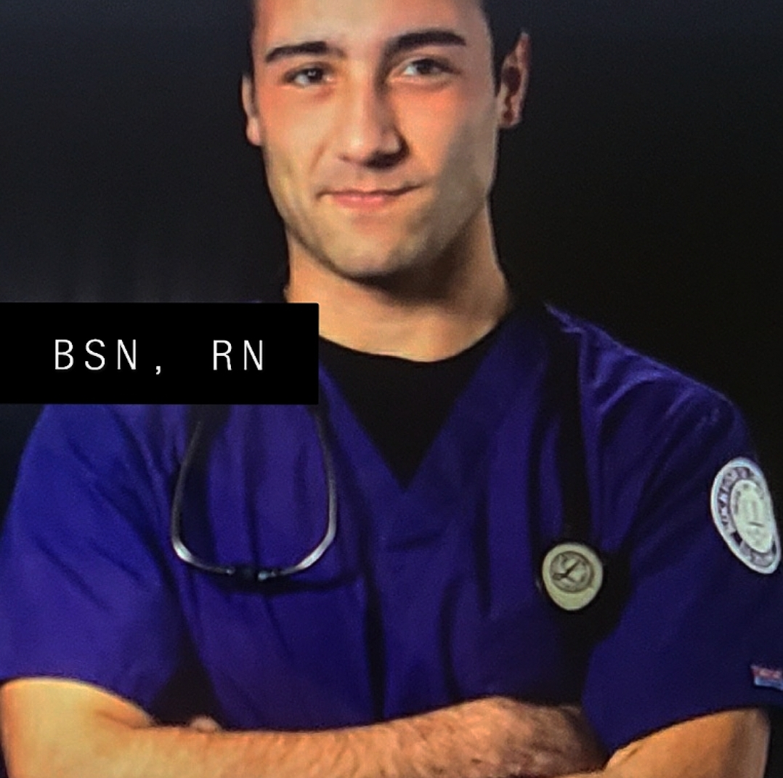 |  | Evan Mendoza  Registered Nurse
Profile  Looking to gain additional experience in an Adult Critical care/ ICU setting and I hope to one day attain a position as a flight nurse in the future. I have extensive healthcare experience with a plethora of credible references. I pride myself on learning quickly, while also practicing safely to provide lifesaving patient care.  PHONE:  773-744-3643  EMAIL:  Oliverlola1228@gmail.com  Contact Hours:  7-days a week  9am-5pm |  | EDUCATION  Rockford University  2017 - 2021  WORK EXPERIENCE  Mercy Heath Cardiac Telemetry & Neurology  08/2021–current  - Provided care for up to six patients with life threatening illnesses in cardiac telemetry  - Recognized signs and symptoms of cardiopulmonary and respiratory emergencies, started standard interventions to stabilize patients  - Initiated and maintained intravenous therapy, obtained 12-lead EKG, interpreted and treated heart dysrhythmias, monitored respiratory ventilation and pulse oximetry, responded to codes  Administered medications, calculated, and titrated medications  - Drew labs, assessed injuries, changed dressings, set nasogastric tubes, foley catheters, and rectal tubes  Generations At Regency -CNA  2018–2021  - Evaluated patients to identify and address wounds, behavioral concerns, and medically relevant symptoms  - Obtained biological specimens for ordered tests and prepared for laboratory transport.  - Cared for clients with diagnoses such as respiratory failure, diabetes, Parkinson's disease, and muscular dystrophy.  Certifications  Advanced Cardiac Life Support  NIHHS Stroke Scale  Critical Care Certified  EKG Certified  Basic Life Support

