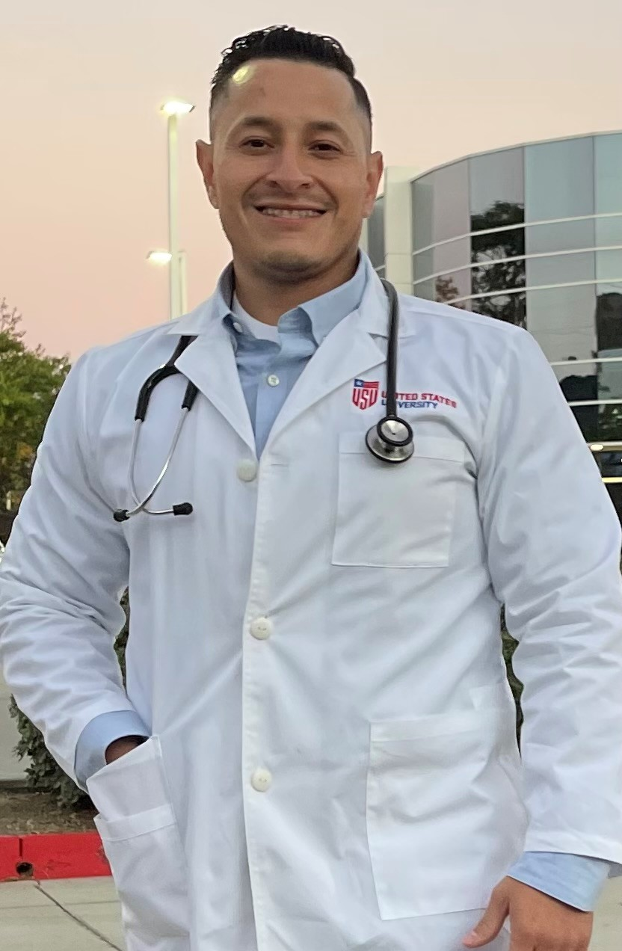 |  | David Rodriguez  Registered Nurse
Profile  Compassionate Registered Nurse with 12 years experience in healthcare. Skilled in providing exceptional care to diverse patient populations with a passion. Loyal and collaborative team player. Proficient in bilingual both English and Spanish language. Seeking an opportunity to work with a team that provides excellent services to the community. Currently a MSN-FNP student at United States University.  Contact  Cell Phone: (760)460-6463  Email:  davidrod1986@yahoo.com  CERTIFICATIONS  Registered Nurse, State of California Lic# 95081204 2015- present  First Aid, CPR and AED certifications, American Red Cross 2020-present  BLS and ACLS Certifications, American Heart Association 2020-present  PALS and TNCC certifications, American Heart Association  2020-present |  | EDUCATION  United States University MSN Nurse Practitioner San Diego, CA  San Diego State University BSN Registered Nurse Calexico, CA  Imperial Valley College Registered Nurse Imperial, CA  Job Corps License Vocational Nurse Los Angeles, CA  Imperial Valley College Certified Nurse Assistant Imperial, CA  WORK EXPERIENCE  Registered Nurse  Pioneers Memorial Hospital – Brawley CA 02/2015-Present  *Surgery/ER/Preop/PACU  *MED surg/DOU/ICU pandemic conditional experience  *Train new RNs in surgery how to set up for varies surgeries  *Prep patients for surgery, preop and post op. Start IV’s and medication administration.  Imperial Heights –Brawley CA 04/2014-01/2015  LVN  Home Health Care – El Centro CA 04/2014–01/2015  LVN  Centinela Prison – Seeley CA 09/2012-09/2013  LVN  ** Provided general care and treatments to inmates with psychiatric and medical illnesses  ** Administered medications including insulin injections  ** Documented medication administration using appropriate forms  ** Orient inmates concerning medications and their use  Imperial Manor- Imperial CA 11/2011-09/2012  CNA  SKILLS  * Surgery Circulator RN * Vitals * CITRIX/QCPR  * Pre-Op RN * Medication * PULSE CHECK  * Emergency Room RN administration * Detail-oriented  * PACU * Sterile Wound Care * Organized  * Patient care * Phlebotomy  * Assessments * IV Management

