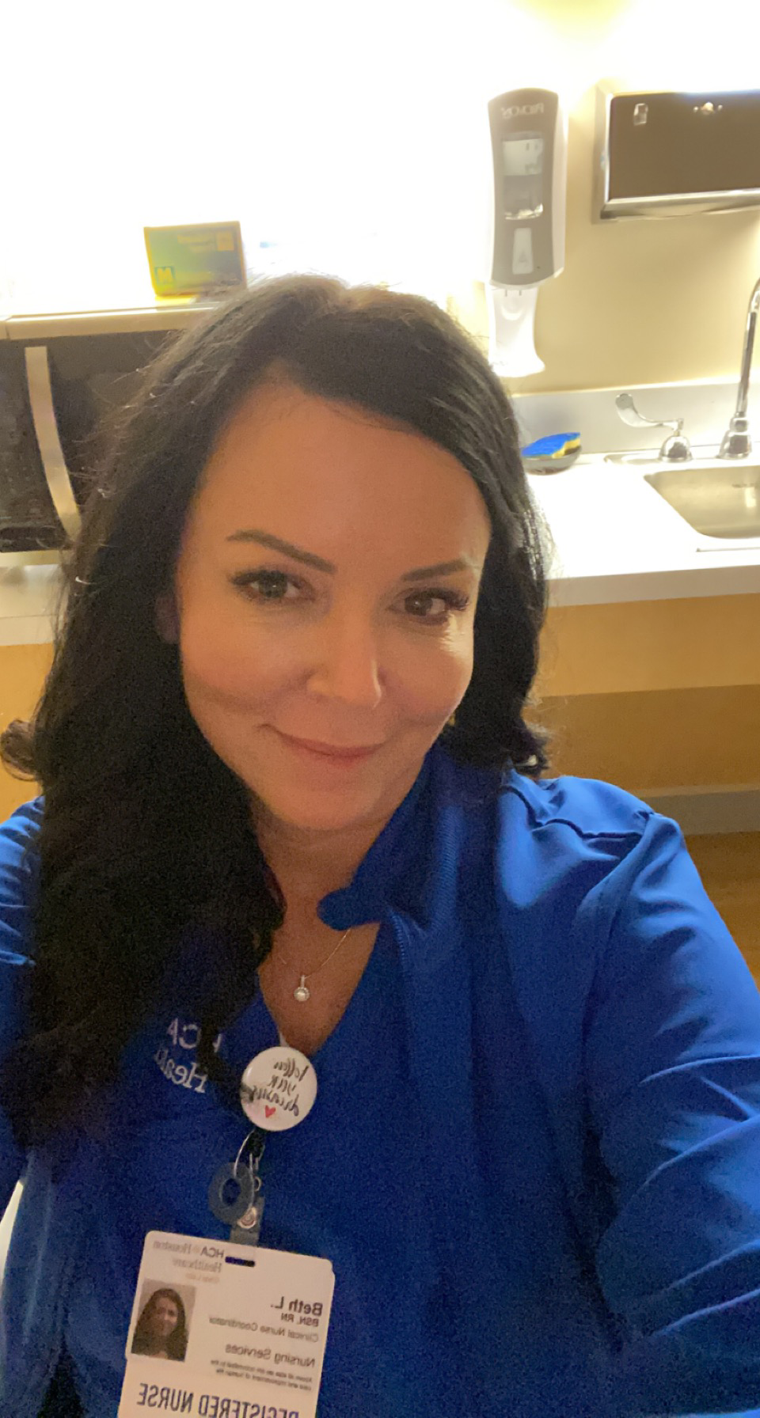 |  | Beth Linkes  Registered Nurse
Contact  PHONE:  734-652-7511  ADDRESS:  2109 Bisbee Rd  League City, TX 77573  EMAIL:  Bethlinkes@yahoo.com  Certifications  TNCC 10/2025  ENPC 08/2025  NRP 05/2023  BLS 11/2023  ACLS 04/2022  PALS 04/2022 |  | EDUCATION  Monroe County Community College, Monroe, MI  - ADN Nursing degree  Western Governors University Utah  Currently enrolled BSN RN program expected graduation 4/2022  WORK EXPERIENCE  November 2021-February 26, 2022  Traveler Pediatric ER RN• AYA Healthcare • Arkansas Children’s Hospital  March 2021–January 27, 2022  CNC RN• ER RN • HCA Houston Healthcare Clear Lake, (Webster, TX)  March 2018—February 2021  RN• ER • Hospitality Health ER, (Galveston, TX)  August 2019–February 2021  RN• ER • UTMB League City Branch, (League City, TX)  July 2016–March 2018  RN• ER • HCA Houston Healthcare, (Houston, TX)  Nov 2014–July 2016  CNC RN• ER • Children’s Hospital of Michigan, (Detroit, MI)  May 2013–October 2014  RN• ER • Toledo Children’s Hospital, (Toledo, OH)  October 2009–May 2013  RN• ER • Mercy Memorial Hospital, (Monroe, MI)  12+ years of Emergency Nursing, extensive Pediatric experience.  leadership  High level of autonomy, seasoned in clinical procedures, team player, strong clinical judgement, professional bedside manner.  Clinical Nurse Coordinator for both Adult and Pediatric facilities.  Community Volunteer hours at local food pantry.  References available upon request.

