**CHERRIELYN TONGCO, BSN, RN** 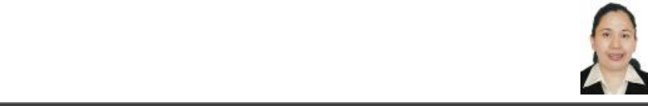

# **A: 4055 Windtree lane Columbus GA, 31907**

# **M: 706-289-8431**

# **E:**[**tongcocherrielyn@gmail.com**](mailto:tongcocherrielyn@gmail.com)

**CAREER OBJECTIVE**: To secure a position as L&D RN with a well-established organization with advancement opportunities utilizing my skills as registered nurse and will expand my nursing experience, competence and knowledge and be able to reinforce the hospital’s operations.

**Core Qualifications**

* Outstanding ability to assess patient needs and provide basic treatments
* Substantial familiarity with nursing procedures and medical terminology
* Extensive knowledge of medical record keeping procedures
* Ability to work well under pressure
* Comfortable with technology; willing and able to learn new software tools
* Clear written and spoken communication skills
* Professional skills: Able to multitask and manage tasks to completion on a timely basis and in an organized fashion

**RN licenses: Compact Texas RN license and currently has a Georgia RN license**

**PROFESSIONAL EXPERIENCE:** With 15 years of continuous professional nursing experience

Currently an ICU/IMCU nurse with 1 yr experience.

10yrs ER RN, 1 MS, 1 yr L&D

3 yrs Psychiatric Nurse

**Present Job : ICU/IMCU RN in Piedmont Northside since December 2021**

**PREVIOUS JOBS:**

**1.Charge nurse Psychiatric Nurse since March 2019 ro February 2022**

**West Central Regional Hospital**

**Address: Schatulga Road Columbus GA 31907**

**2.MSICU/CVS at St.Francis Emory Healthcare since February 2021-November 2021**

**3. ER RN,L&D RN and MS RN in Tondo Hospital, Philippines for 10yrs.**

**Address: 1171 Jose Abad Santos, Tondo Manila Philippines**

**Aug 28 2007 Feb 11 2017**

**Unit Assigned: Med/Surg:**

**Aug. 2007-December 2008**

**DELIVERY ROOM/OR complex: January 2009-January 2010**

**ER: Feb 2010 to Feb 2019**

**TRAINING and AFFILIATION:**

* Advanced Cardiac Life Support (ACLS) License Valid until June 2022
* Basic Life Support (BLS) License, (CPR and AED), ECG and Arrhythmia Recognition Training Valid until June 2022
* First Aid and CPR expiration Valid until Feb 2023
* NIHSS Certification Valid until June 202
* Knoledgeable un Epic Charting and Cerner Charting
* Comfortable in caring for vented patients in ICU

**EDUCATION: BSN**

**Bachelor of Science Nursing**

**University of the City of Manila / Pamantasan ng Lungsod ng Maynila**  BSN: 2002 – 2006

Reference:

1.Sarah Callaway

706 660 3060

Nurse Supervisor WCRGH

2.Hope-Love Gutierrez

615-956-9234

Nurse Supervisor WCRGH

3.Michelle Williams

410-739-7539

Charge Nurse WCRGH

PRN ICU nurse St.Francis Emory Healthcare

4. Kennedy Dela Cruz

706 289 9196

Senior Nurse WCRGH