Registered Nurse at Reading Health System on C3 a Medical Surgical Floor from September 2013 until September 2019
- Shows leadership values through the Unit Facilitator role educated through the LEAD class
- Assisted adult patients with multiple acute and chronic diagnosis including acute blood loss related GI issues as well as chronic diagnosis such as COPD, DM and asthma as well as education on these subjects customized to each patient based on diseases tailored to the patient’s individual needs
- Provided behavioral/emotional support and supervision for those with dementia, Alzheimer’s, and other mental health diagnosis in the geriatric and adult population
- Monitored post-op vitals, set up PCA pump, fluids and reviewed and carried out post-op orders, oriented patients to the floor
- Wound Care ie: cleaning, packing, dressing
- Assisted with bedside procedures such as: I&D, bone biopsies, and wound biopsies, staple removal etc. and stiches removal
- Education provided via Get Well Network, Krames and Care notes in the inpatient setting
- Advanced skill in IV insertion cautious care of ports and PICC lines
- Provided palliative care treatment in inpatient setting while giving emotional support to patient and family as well as decedent care
Children’s Health Center September 2019 until October 2021
- Team Lead on current Asthma JC team working towards Joint Commission Certification
- Manage and Educate over 140 children/family with high lead levels educating, and ensuring follow up
- Assist in well child visit with proper immunization administration education on well child
- Care of the Pediatric Population ages 2 day to adulthood
Bayada Home Health November 2021 until Current
Autonomous management of post hospitalization acute skilled needs while collaborating with patient/family and PCP team
Summary
- Maintained quality of care systems and standards
- Delivered high quality care and compassionate treatment to indignant and low-income patients of the community
- Sound, ethical and independent decision-making ability consistent with Tower Health protocols
- Excellent team collaboration and communication skills as well as ability to excel in personal performance
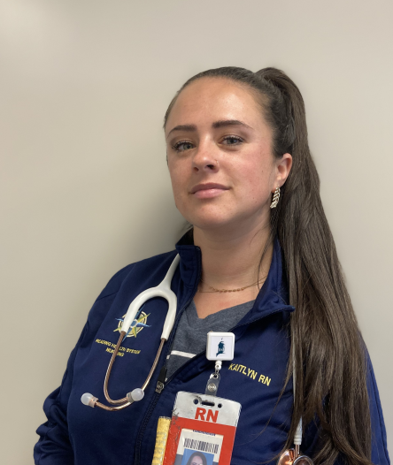

Kaitlyn Whiteman CMSRN
 Reading Pa 19611
 484 268 3899

License number RN 653489
Kaitlyn10sztuwhite@gmail.com

Education
Reading Health System School of Health Sciences Graduation in 2013 -Diploma
Pursuing BSN at Chamberlain School of Nursing
Certification of medical surgical nursing 2018

References
Jillian Hole MSN RN CMSRN (former manager) 484-336-3627
Jennifer Pollock BSN RN CSMSRN (former co-worker) 610-763-3976
Valeria Safe RN (former co-worker) 484 794 0430
Nicole Fisher RN (current co-worker) 484 650 9803

