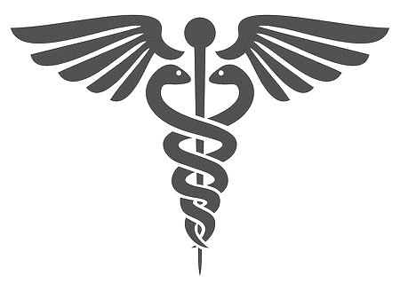

REBECA FLORES

ASSOCIATES DEGREE IN NURING

Laredo College

2022 Graduate

RN LICENSE NUMBER:

1086488

**Ana K. Ibarra**

Safari Pediatrics

Clinical Supervisor

t: 956-724-7445

**Shelsey Hernandez**

Medical Office Assistant

t: 956-290-6698

e: shelsey8@hotmail.com

**Dongyeol Yeo**

Laredo College Instructor

t: 956-764-5903

e: dongyeol.yeo@laredo.edu

REFERENCES

* Patient Safety & Care
* Patient Assessment
* Patient & Family Education
* Time Management
* Critical Thinking
* Empathy
* Teamwork & Communication

SKILLS

BLS, Basic Life Support

American Heart Association

Expires 07/2022

CERTIFICATIONS

EDUCATION

experience

STUDENT NURSE

Laredo College ADN Program | AUGUST 2020 – Present

Clinical Practicum in Specialty Units and Preceptorship

* Monitor 3 assigned patients upon preceptorship, updating information on vital signs and treatment progress.
* Documented data related to patient’s care, including assessment results, interventions, medications, patient’s response, or treatment records
* Assessed patient’s conditions, assisting with ordering, and evaluating tests as needed.

CERTIFIED NURSE ASSISTANT WITHIN THE COVID UNIT

Las Alturas, Laredo, TX | OCTOBER 2021 – FEBRUARY 2022

* Answering call buttons and alerting nurses to emergencies
* Monitoring patients’ needs and reporting any issues to healthcare personnel
* Repositioning patients in bed and assisting with ambulating from bed to a chair or wheelchair and back.
* Helping patients with their daily needs such as eating, bathing, dressing, and toileting.
* Measuring vital signs including blood pressure, oxygen level, and temperature

MEDICAL ASSISTANT

Safari Pediatrics, Laredo, Tx | JUNE 2018 – NOVEMBER 2021

* Interview patients with family members to obtain medical information and measure vital signs, weight, and height
* Record patients’ medical history and test results in their medical records
* Prepare and administer vaccines/ antibiotic injections as directed by a physician.
* Perform routine laboratory test and sample analyses.
* Clean and sterilize exam room and dispose of contaminated supplies.
* Help physicians examine and treat patients such as assisting in removing sutures.

956-326-9181

Rebeca.floresrn2022@gmail.com

1602 Jacaman Road Apt 907, Laredo Texas