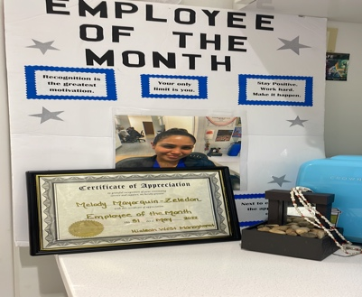 |  | Melody Mayorquin-Zeledon  Licensed Practical Nurse
Profile  Highly motivated self-starter looking for a career in nursing to support my passion for helping others. Based on my previous experience as a Customer Service Manager and a Flight Attendant I bring proven experience for serving others with a problem-solving and team player attitude. Flying during a pandemic while attending school and becoming certified as an LPN, I was able to successfully handle multiple priorities while achieving my goals. I can also fluently deliver compassionate healthcare to others in both English and Spanish.  Contact  PHONE:  786-263-8825  EMAIL:  Aqua.melody26@gmail.com  References available on request |  | EDUCATION  Miami-Dade College 2022 – Present  Working my to getting my RN license  Southeastern College - 2021  Graduated top of class with academic excellences. GPA 4.0  Miami-Dade College - 2012  Associate of Arts  WORK EXPERIENCE  Mount Sanai MedicalCenter  July 2021- Present  - Multi-Specialty Physician Offices in Outpatient care  - Developing skills and knowledge in procedures preparations such biopsies, vasectomy, BCGs stent removals and Urodynamic  - Patient wound care, blood drawn, labs, per-charting, prior authorization, medication administration, vitals, catheter change, SPT catheters, stoma bag change, and disinfecting.  Red Cross Volunteer Service  July 2020- Present  - Providing phone calls to veterans during the pandemic to check in on them and their overall well-being.  Spirit Airlines - Flight Attendant  July 2017 - Present  - Responsible for attending to the safety and comfort needs of passengers aboard domestic and international flights while complying with FAA requirements.  - Perform a range of tasks including demonstrating emergency procedures, directing passengers, and performing safety checks.  - Quickly adapting to the changing requirements for travel during a pandemic  Swissport - Supervisor  January 2013 - July 2017  - Provided airport ground and cargo handling services for multiple airlines.  - Successfully coordinated many of the logistics and supply chain operations required to efficiently enable timely departure and arrival of flights.  - Investigated and resolved customer inquiries and complaints in an empathetic manner.  SKILLS  - IV Therapy Certified  - CPR Certi  - Vital signs  - Administration of Medication  - Documentation  - Infection Control Precaution  - Wound Care  - Age Appropriate Care  - Coordinating Care with Team

