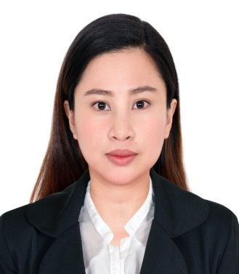**FREDDA ZHEILLAH REAL MAGUINSAY**

Phone No: (872) 210-7014

Email: [freddazheillahreal@yahoo.com.ph](mailto:freddazheillahreal@yahoo.com.ph)

4346 North Winchester Ave. Apt. 1E, Chicago Illinios 60613

**OBJECTIVE**

To work in a company that provides equal and challenging opportunities where I can be able to use my abilities, knowledge and to bring excellent record of nursing education and experience outstanding interpersonal skills to attain the maximum level of patient care.

**JOB DESCRIPTION**

* Administering medications to patients and monitoring them for side effects and reactions
* Monitoring patients vital signs
* Carry out Doctor’s order
* Assessing , implementing, planning and evaluating patient nursing care plans

**SKILLS AND AREAS OF EXPERTISE**

* Skilled in assessing, planning, implementing, documenting and managing patient care
* Knows how to handle emergency situations in a safe manner
* Well-versed in administering medications and treatments as prescribed by a Physician

**WORKING EXPERIENCE**

* Staff Nurse at SINDANGAN DISTRICT HOSPITAL From September 2013 to

September 2015 . Located at Poblacion,Sindangan,Zamboanga del Norte, Philippines

* Public Health Nurse under Nurses Deployment Project of Department of Health Region 9, Philippines from March 2016 to December 2016.
* General Nurse under Premier Health Care Home Medical Abu Dhabi from September 2017 until September 2019

**ACCOMPLISHMENTS/TRAININGS/SEMINARS**

**IT Graduate Major in Computer Office Management**

Year 2007-2009

**USRN** (September 2022)

**HAAD PASSER ( Abu Dhabi Registered Nurse**) ( September 2016)

**Registered Nurse in the Philippines** (Year 2013)

**Basic Life Support (Accredited by American Heart Association**

Infinity Medical Services, Abu Dhabi , UAE

Valid until October 2020

**Infection control**

Held on January 13, 2018

**Manual Handling**

Held on March 18, 2019

**Wound Care**

Held on July 15, 2019

**Airway Management**

Held on April 14, 2019

**Neuro-Degenerative Disease Forum**

Held on December 7, 2018

**Cataract and Glaucoma**

Held on January 24-26, 2019

**EDUCATIONAL BACKGROUND**

College : Dipolog Medical Center, A De La Salle Supervised School

Dipolog city

Course : Bachelor of Science in Nursing

Year 2009-2013

College : Saint Joseph College

Sindangan, Zamboanga del Norte

Course: 2 Year Information Technology Major in Computer Office

Management

Year 2007-2009

Secondary: Sindangan National High School

Sindangan, Zamboanga del Norte

Primary: Binuangan Elementary School

Binuangan, Sindangan, Zamboanga del Norte

**PERSONAL DATA**

Name : Fredda Zheillah Real Maguinsay

Address : 4346 North Winchester Ave. Apt. 1E, Chicago Illinios 60613

Age : 33 years old

Height : 5’0”

Weight : 45 kilos

Civil Status : Married

Religion : Christian

Date of Birth: September 13, 1989

Place of Birth: Sindangan Zamboanga del Norte, Philippines

Nationality : Filipino

Husband’s Name: Glenn Hugglan Maguinsay

Occupation: Care Giver

Person to be contact in case of emergency: Glenn Hugglan Maguinsay

Contact Number : (773) 691-0129

**CHARACTER REFERENCES**

**DR. MARCELITO LACAYA, MD**

Chief of the Hospital II

Sindangan District Hospital

Sindangan Zamboanga del Norte, Philippines

Contact number: +63**927-8520-968**

**DR. DYRLEE ENRIQUEZ**

Contact number: **+63905-312-6160**