

PO Box 400
Birmingham, MI 48012
Office: 313-204-6332

September 16, 2020

Loving Hands Care Management
PO Box 400
Birmingham, MI 40812

To Whom it May Concern:

This letter is to verify that Dominique Fairweather is currently employed with Loving Hands Care management.

If you have any further questions, please feel free to contact Niamani Smith at 313-204-6332.

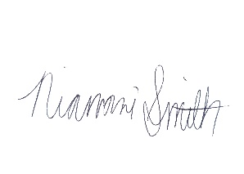
Sincerely,

Niamani Smith

